EX NO: 8a | SIMULATION AND ANALYSIS OF BPSK MODULATION USING CONSTELLATION DIAGRAMS IN MATLAB
DATE:

Objective

i) To generate BPSK symbols from a binary data sequence using phase-shift keying principles.
ii) To Plot and analyze the BPSK signal constellation in the In-Phase (I) and Quadrature (Q) plane.
iii) To investigate the effect of noise on constellation points and evaluate the resulting degradation in symbol detection performance.

Matlab code
clc;
clear;
close all;
%% Objective 1: Generate BPSK symbols
N = 1000; % Number of bits
data = randi([0 1], N, 1); % Random binary sequence
% BPSK Mapping
bpsk_symbols = 2*data - 1;
%% Objective 2: Plot BPSK Signal Constellation
figure;
subplot(1,2,1);
scatter(real(bpsk_symbols), imag(bpsk_symbols), ...
30, 'filled');
hold on;
xline(0,'k','LineWidth',1.5);
yline(0,'k','LineWidth',1.5);
grid on;
axis equal;
xlim([-1.5 1.5]);
ylim([-1 1]);
xlabel('In-Phase (I)');
ylabel('Quadrature (Q)');
title('Ideal BPSK Constellation');
%% Objective 3: Add Noise and Evaluate Performance
SNR = 5; % Signal-to-Noise Ratio (dB)
rx_signal = awgn(bpsk_symbols, SNR, 'measured');

subplot(1,2,2);
scatter(real(rx_signal), imag(rx_signal), ...
15, 'filled');
hold on;
xline(0,'k','LineWidth',1.5);
yline(0,'k','LineWidth',1.5);
grid on;
axis equal;
xlim([-2.5 2.5]);
ylim([-2 2]);
xlabel('In-Phase (I)');
ylabel('Quadrature (Q)');
title(['Noisy BPSK Constellation (SNR = ', num2str(SNR), ' dB)']);
%% Symbol Detection
detected_bits = real(rx_signal) > 0;
% Calculate Errors
num_errors = sum(data ~= detected_bits);
BER = num_errors/N;
fprintf('Number of Transmitted Bits : %d\n', N);
fprintf('Number of Bit Errors : %d\n', num_errors);
fprintf('Bit Error Rate (BER) : %f\n', BER);

Procedure:

Objective 1: Generate BPSK Symbols from a Binary Data Sequence Using Phase-Shift Keying Principles
- Initialize the MATLAB environment and define the number of bits.
- Generate a random binary sequence consisting of 0s and 1s.
- Apply BPSK modulation by mapping binary 0 to −1 and binary 1 to +1.
- Store the generated BPSK symbols for further processing.
- Verify that the symbol sequence contains only two distinct symbol values.
- Prepare the modulated symbols for constellation analysis.

OUTPUT:

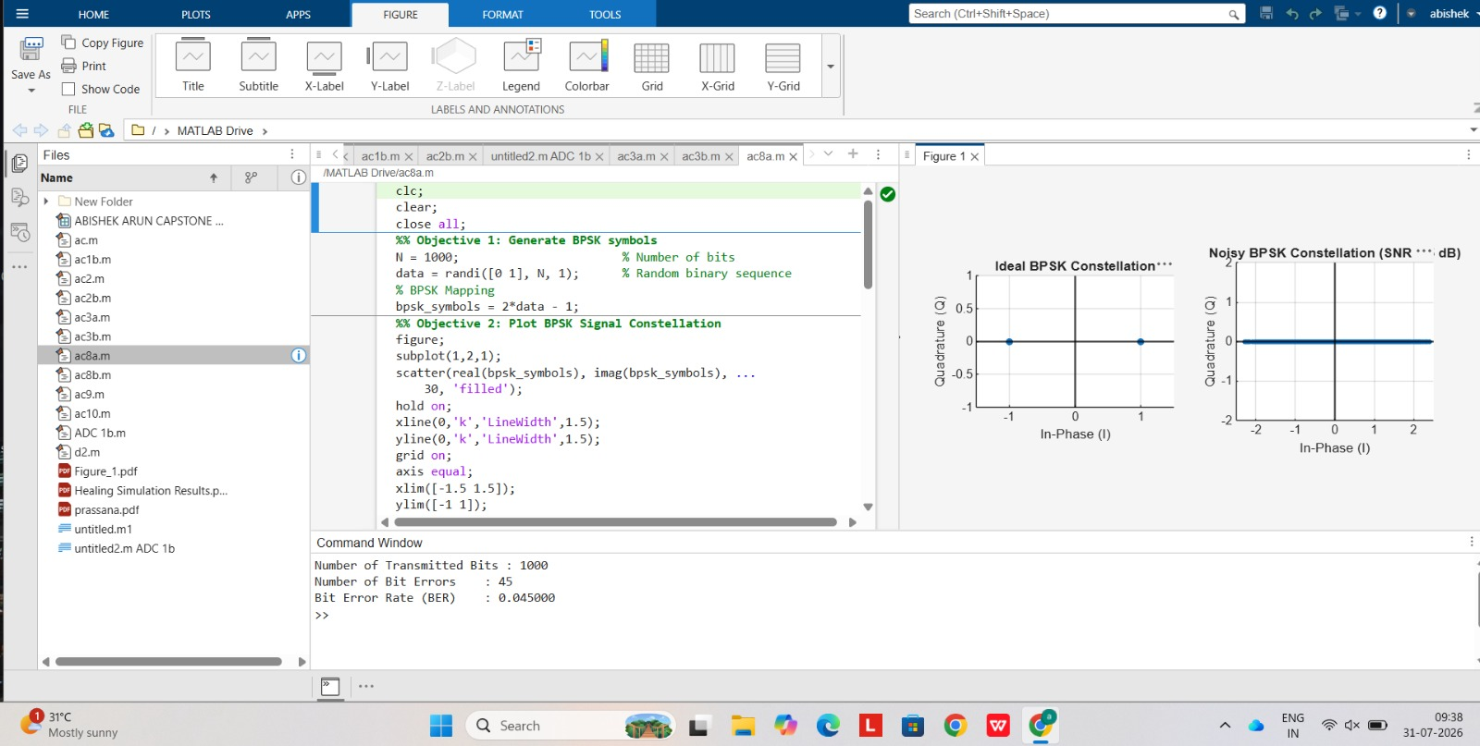

Fig: Signal Constellation for BPSK Symbols

Result BPSK symbols were successfully generated from the binary data sequence using phase-shift keying modulation.
.
Objective 2: Plot and Analyze the BPSK Signal Constellation in the In-Phase (I) and Quadrature (Q) Plane
- Use the generated BPSK symbols as inputs for constellation plotting.
- Assign the real part of the symbols to the In-Phase (I) axis.
- Set the Quadrature (Q) component to zero for all symbols.
- Plot the constellation points on the I–Q plane using a scatter plot.
- Draw the horizontal and vertical axes through the origin and label them appropriately.
- Analyze the constellation diagram and identify the symbol locations corresponding to binary 0 and binary 1.

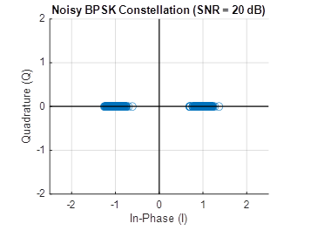
Fig. 2: Noisy BPSK Constellation

Result : The BPSK constellation was successfully plotted in the In-Phase (I) and Quadrature (Q) plane, showing two distinct symbol points corresponding to binary 0 and binary 1 for the given SNR.
EX NO: 8b | SIMULATION AND ANALYSIS OF QPSK MODULATION USING CONSTELLATION DIAGRAMS IN MATLAB
DATE:

Objective
i) To generate QPSK symbols from a binary data sequence using quadrature phase-shift keying principles.
ii) To plot and analyze the QPSK signal constellation in the In-Phase (I) and Quadrature (Q) plane.
iii) To investigate the effect of noise on constellation points and evaluate the resulting degradation in symbol detection performance.

Matlab code

clc;
clear;
close all;

%% Objective 1: Generate QPSK Symbols
N = 1000; % Number of bits
data = randi([0 1], N, 1); % Random binary sequence

% Ensure even number of bits
if mod(N,2)~=0
data = [data; 0];
N = N + 1;
end

% Group bits into pairs
bit_pairs = reshape(data,2,[])';

% QPSK Mapping

qpsk_symbols = zeros(size(bit_pairs,1),1);
for k = 1:size(bit_pairs,1)
if isequal(bit_pairs(k,:),[0 0])
qpsk_symbols(k) = (1+1j)/sqrt(2);
elseif isequal(bit_pairs(k,:),[0 1])
qpsk_symbols(k) = (-1+1j)/sqrt(2);

elseif isequal(bit_pairs(k,:),[1 1])
qpsk_symbols(k) = (-1-1j)/sqrt(2);
elseif isequal(bit_pairs(k,:),[1 0])
qpsk_symbols(k) = (1-1j)/sqrt(2);
end
end

%% Objective 2: Plot QPSK Constellation

scatter(real(qpsk_symbols),imag(qpsk_symbols), 30);
xlim([-1 1])
ylim([-1 1])
hold on;

xline(0,'k','LineWidth',1.5);
yline(0,'k','LineWidth',1.5);

grid on;
axis equal;

xlabel('In-Phase (I)');
ylabel('Quadrature (Q)');
title('Ideal QPSK Constellation');

%% Objective 3: Add Noise and Evaluate Performance
SNR = 5;

rx_signal = awgn(qpsk_symbols,SNR,'measured');

figure;
scatter(real(rx_signal),imag(rx_signal), 15);
hold on;

xline(0,'k','LineWidth',1.5);
yline(0,'k','LineWidth',1.5);

grid on;
axis equal;
xlabel('In-Phase (I)');
ylabel('Quadrature (Q)');
title(['Noisy QPSK Constellation (SNR = ',num2str(SNR),' dB)']);

%% Symbol Detection
detected_bits = zeros(length(rx_signal)*2,1);
for k = 1:length(rx_signal)
I = real(rx_signal(k));
Q = imag(rx_signal(k));
if I>0 && Q>0
bits = [0 0];
elseif I<0 && Q>0
bits = [0 1];
elseif I<0 && Q<0
bits = [1 1];
else
bits = [1 0];
end
detected_bits(2*k-1:2*k) = bits;
end

%% BER Calculation
num_errors = sum(data ~= detected_bits);
BER = num_errors/N;
fprintf('Number of Transmitted Bits : %d\n',N);
fprintf('Number of Bit Errors : %d\n',num_errors);
fprintf('Bit Error Rate (BER) : %f\n',BER);

Objective (i): Generate QPSK Symbols from a Binary Data Sequence Using Quadrature Phase-Shift Keying Principles

Procedure:
- Initialize the MATLAB environment and define the number of bits.
- Generate a random binary sequence consisting of 0s and 1s.
- Group the binary sequence into pairs of bits.
- Apply QPSK modulation by mapping each bit pair to a unique constellation point.
- Generate the corresponding complex QPSK symbols.
- Verify that four distinct symbol values are obtained.
- Store the generated symbols for constellation analysis.

OUTPUT GRAPH
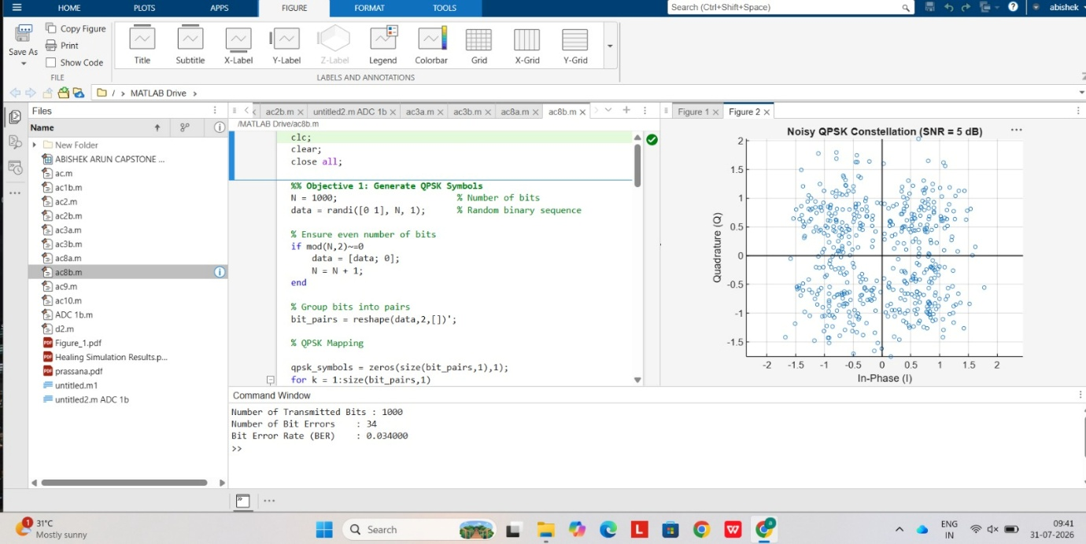

Fig. 1: Signal Constellation for QPSK Symbols

Result
QPSK symbols were successfully generated from the binary data sequence using quadrature phase-shift keying modulation.

Objective (ii): Plot and Analyze the QPSK Signal Constellation in the In-Phase (I) and Quadrature (Q) Plane

Procedure
- Use the generated QPSK symbols for constellation plotting.
- Extract the real component as the In-Phase (I) coordinate.
- Extract the imaginary component as the Quadrature (Q) coordinate.
- Plot the constellation points on the I–Q plane using a scatter plot.
- Draw the horizontal and vertical axes through the origin.
- Identify the four symbol locations corresponding to the four possible bit pairs.
- Analyze the distribution of symbols in the four quadrants.

Fig. 2: Noisy QPSK Constellaion

Result
The QPSK constellation was successfully plotted in the In-Phase (I) and Quadrature (Q) plane, showing four distinct symbol points corresponding to the bit pairs 00, 01, 11, and 10.

